**HTML Interview Question**

1. What are HTML tags?

Answer: Everything in the HTML we write it in the tag. It defines how the content to be structure Eg: <p>, <heading>

1. What is HTML element?

Answer: A combination of stating tag, ending tag and some content

1. Is HTML tag and HTML element are same?

Answer: No, because tag is like a primary component of HTML(<p>). HTML element is (<p>Matter</p>).

1. What are attributes?

Answer: Attributes are used along with the tags, to define more specific characters of the element. Eg: <img src=”” alt=””> and <a href=”” target=””>

1. What is VOID/EMPTY elements?

Answer: <br>, <hr>, <img> they don’t have any content

1. What is collapsing white space and advantages?

Answer: If we provide 10 white spaces in HTML file, HTML will collapse it in single white space. Advantages – readability and understandability of the code.

1. What are Entities? 🡪 need to check

Answer: to represent symbols / characters we use entities. Eg: &amp;

1. What are the different types of list in HTML?

Answer: Order list (if list required order), unordered list (if list doesn’t require order) and description list (if we require term and the description then we can use description list)

1. What is metadata in HTML?

Answer: metadata is the information of out HTML document that we represent using the <meta> tag, it will be in html head tag. We have attributes like charset, name, content.

1. Define HTML web page Layout structure?

Answer: Heading, Navigation, aside, main and footer. Semantic and non-semantic tags

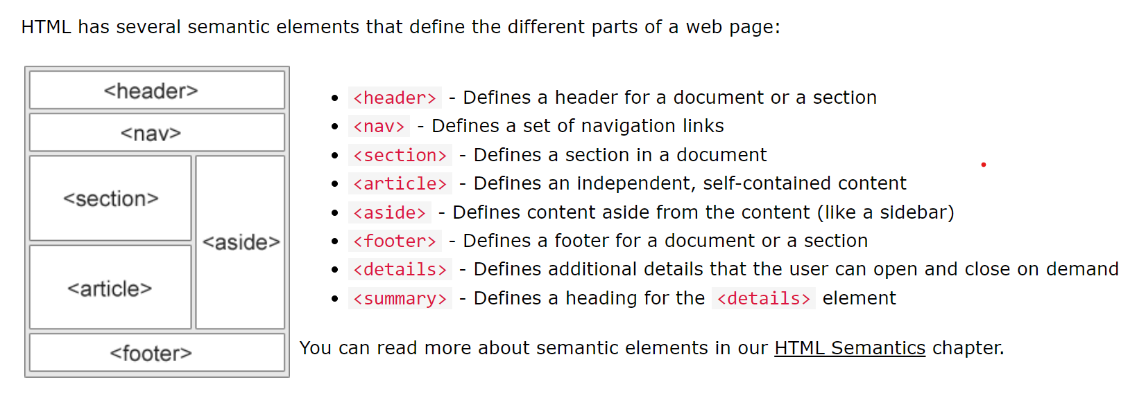

1. What are various text formatting tags?

Answer: <b>, <em>, <i>, <strong>, <mark>, <sub>, <sup>, <del>

1. What is the difference between <strong>, <b> and <em>, <i>?

Answer: add some ink to b tag and to add style we use <i> tag

Whereas if we use the strong tag in the content, the content will be important, the content in em tag is to emphasis the content or stress the content.

1. Basic Hierarchal structure of HTML tags in a document?

Answer: <!DOCTYPE html>

<html>

<head>

<meta>

<title>

<link>

<style>

</head>

<body>

</body>

</html>

1. Is it possible to nest/embedded/show a web page inside a web page?

Answer: Yes, by using <iframe> tag we can achieve. Iframe means inline tag, attributes src, width and height

1. Can we club 2 or more rows in a table?

Answer: Yes, it is possible to club 2 or more rows in a table. To define table, we have <table> tag and inside the table tag to define a row we have <tr> tag and inside the <tr> tag we can use rowspan attribute to club 2 or more rows. Same for columns we use colspan.

1. How to specify links in HTML?

Answer:

17)W

Answer:

18)W

Answer: